COMP 4220 Machine Learning Final Project, Fall 2020
Due date: December 15th, 11:59 PM

- Introduction
In Machine Learning, we learned about many techniques used to classify and categorize many kinds of datasets. We went over Linear Regression, Gradient Descent, Stochastic gradient descent, polynomial regression, linear classification, Ridge Regression, Decision Trees Classifier/Regression, Random Forest Classifier/Regression, just to name a few. In this report we explore 2 kinds of datasets: Credit Card Fraud for Classification and Auto-MPG for Regression. For Auto-MPG, I got an accuracy score of 87%, 85%, 80%, and 89% for Linear Regression, Support Vector Regression, KNeighbors Regression, and Artificial Neural Network respectively. For the Credit Card Fraud dataset, I got an accuracy score of 94%, 99%, and 93% for Linear Classification with SMOTE, Decision Tree Classification with Smote, and Artificial Neural Network respectively.
- Auto-MPG
We start with the Auto-MPG Regression dataset. On First inspection it is a small dataset and should be easy and fast to train on different model algorithms. We have 9 features, in the dataset: MPG, Cylinders, Displacement, Horsepower, Weight, Acceleration, Model Year, Origin, and Car Name. We can see that MPG is a continuous value and our feature we will be basing our models on. Cylinders is a multi-valued discrete variable which we will split into 5 dummy categories. Displacement and weight are highly correlated, meaning they are related and dependent on each other. Origin is most likely the country which the car comes from and model year is self-explanatory. When looking at the describe table, we see that horsepower isn’t displayed. Perhaps there are some missing values, and when looking at unique values, we can see there is a question mark. (‘?’) Searching for question marks in the data set in horsepower, we see 6 values are missing. This is easy to rectify; all we need to do is convert the question mark into NaN and the horsepower feature from an object into a float. When looking at how much the missing data is comprised of in regards to the whole dataset of 398 values, we can either drop the missing values or fill the missing values with the median of horsepower.

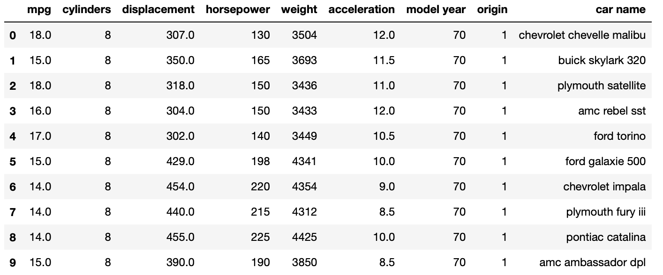

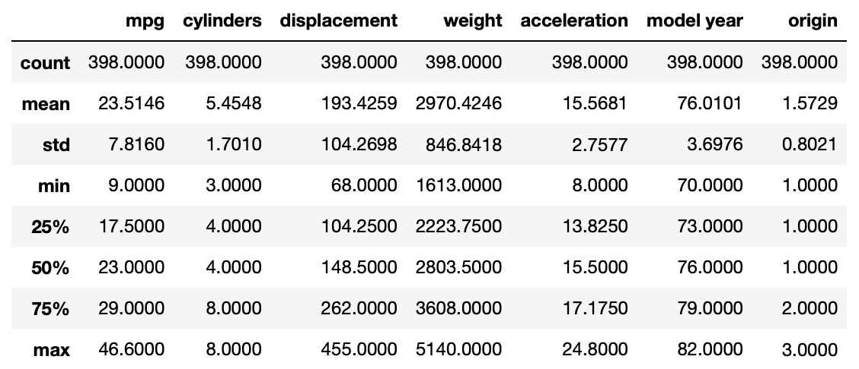

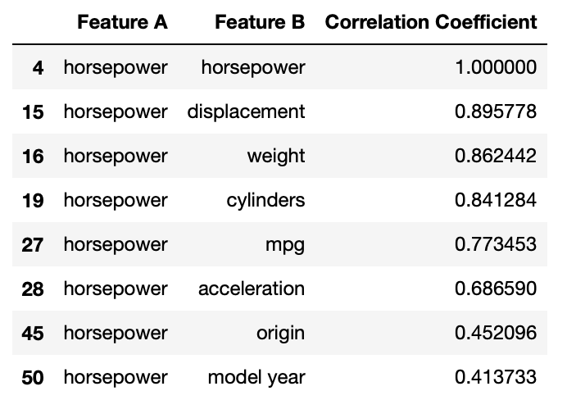
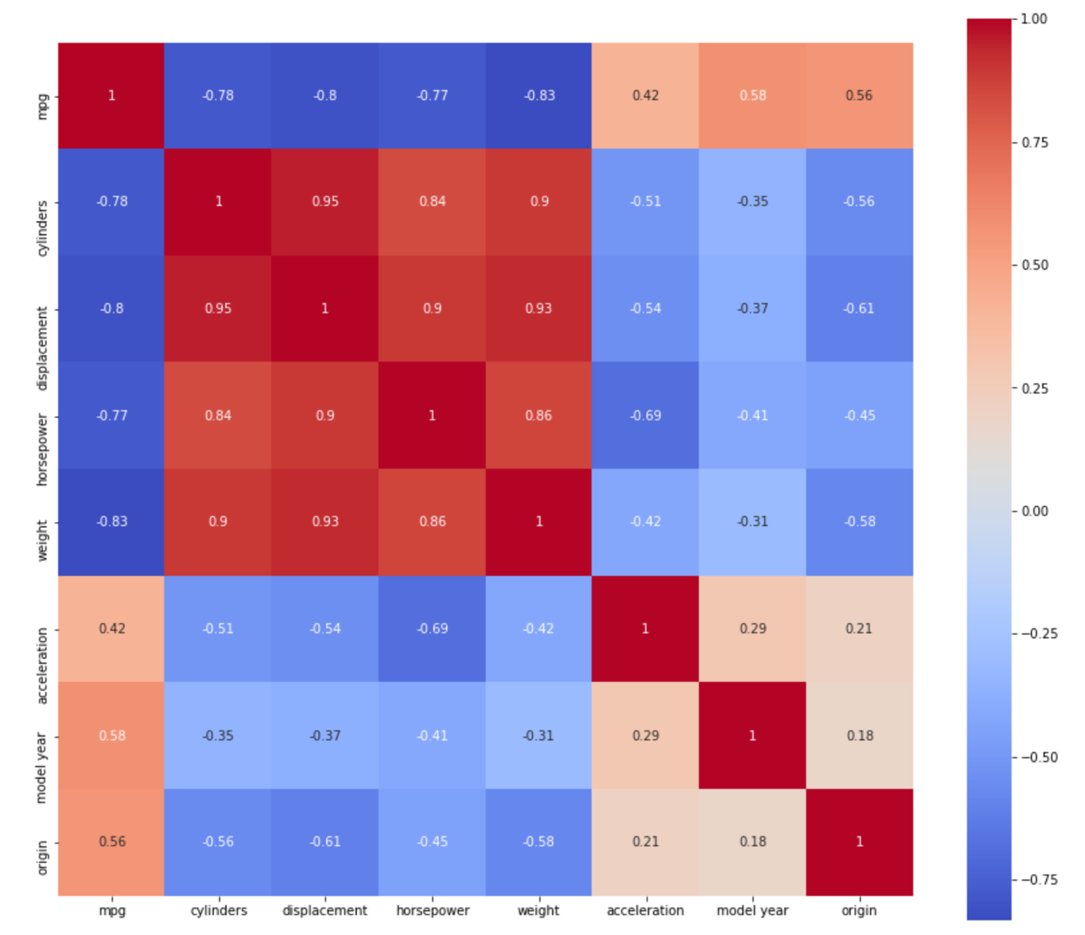

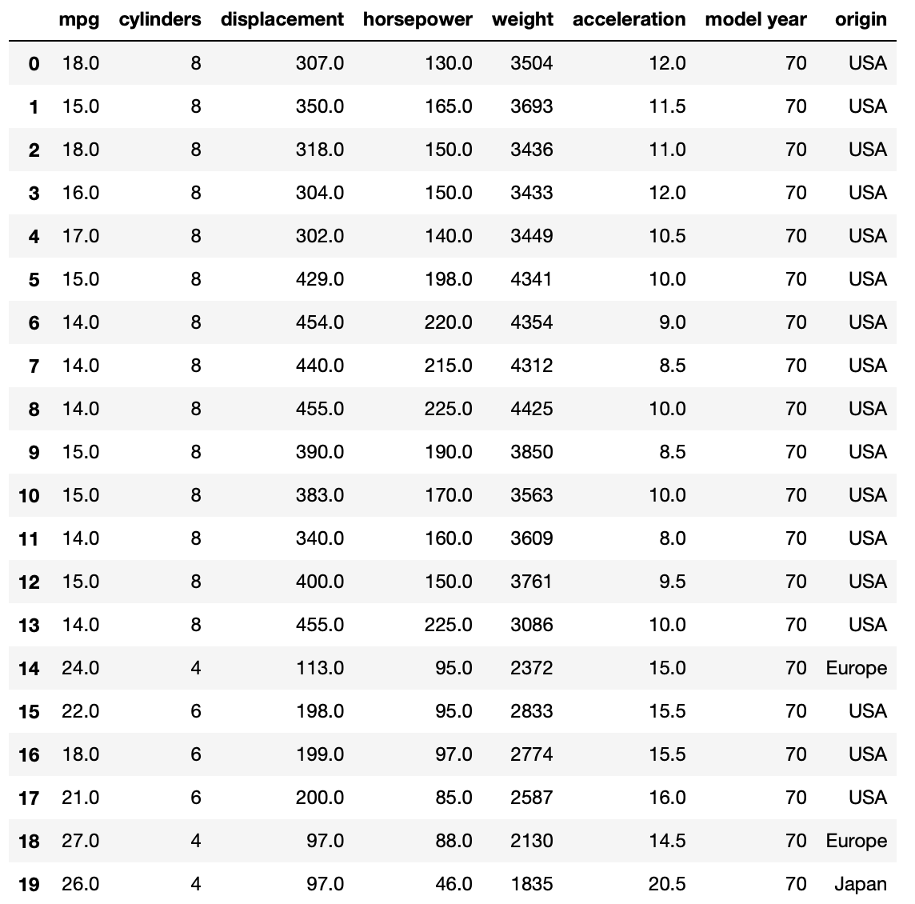

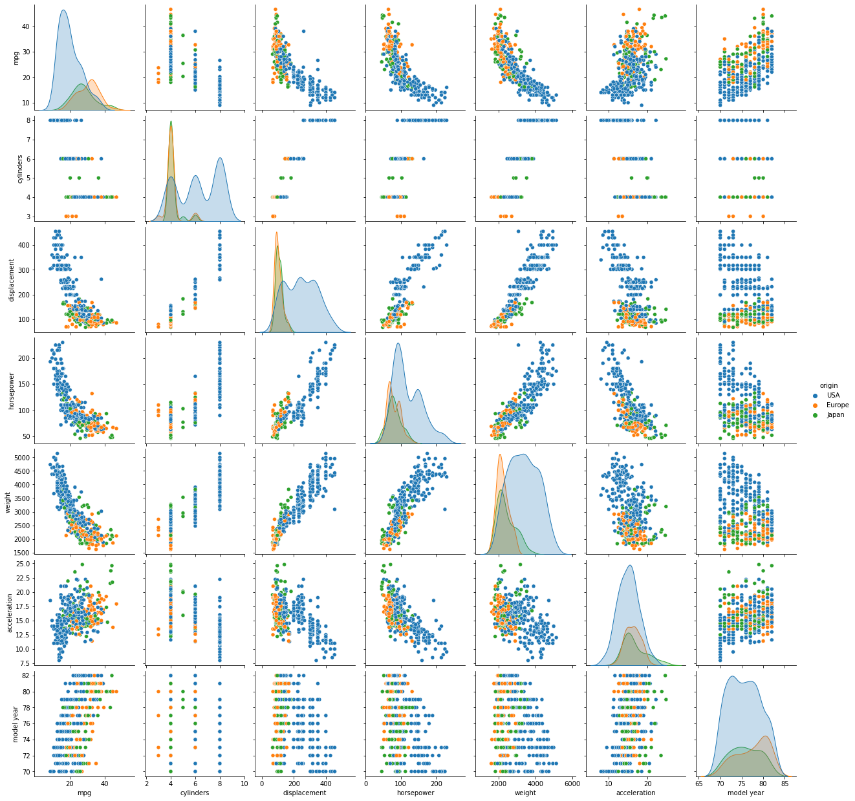

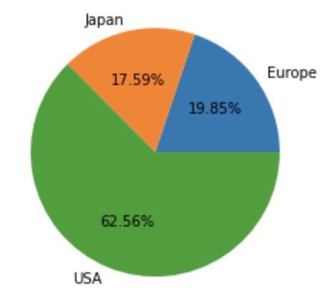

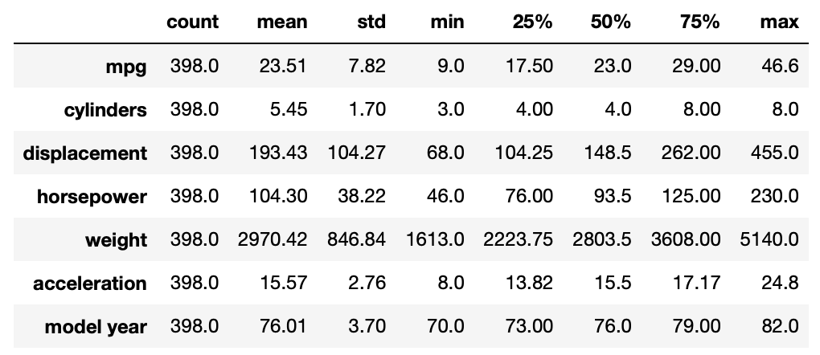

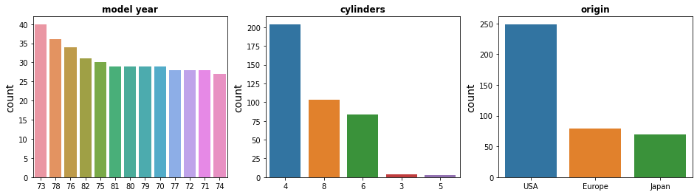
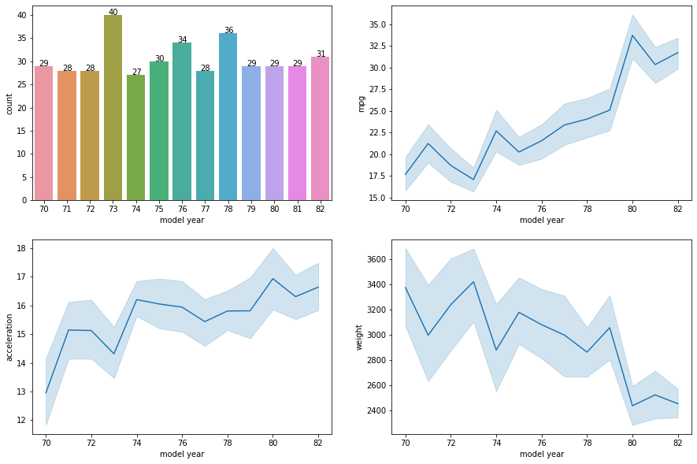

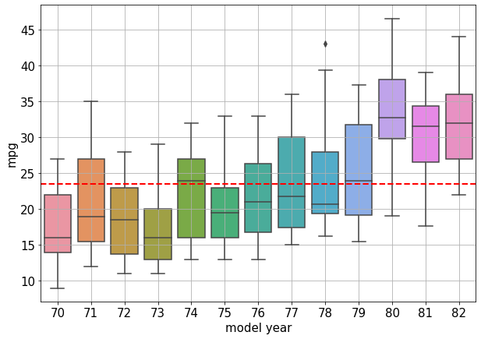

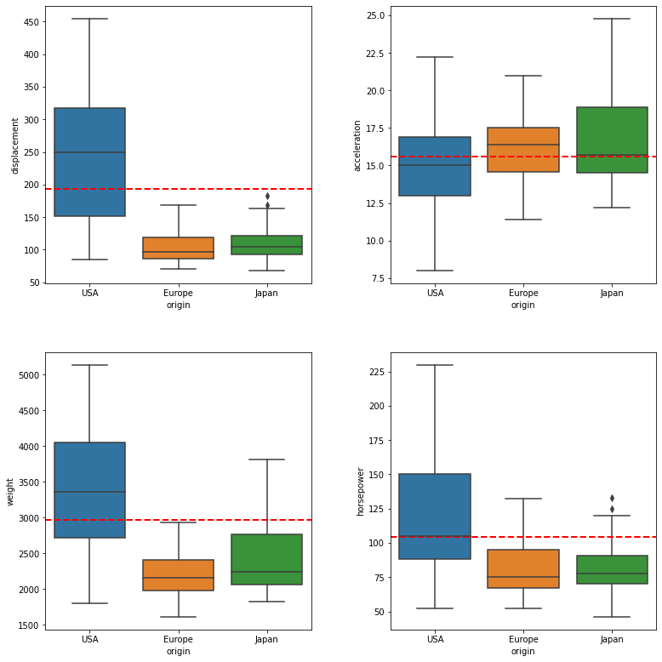

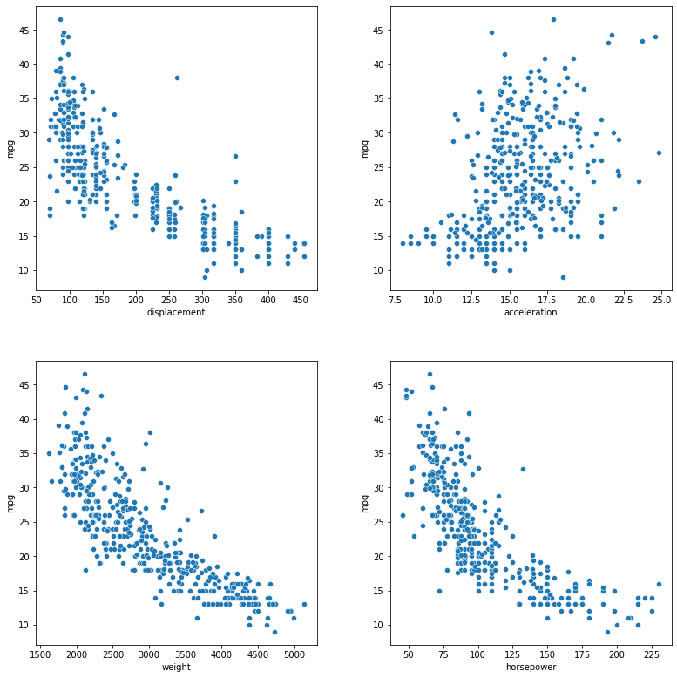
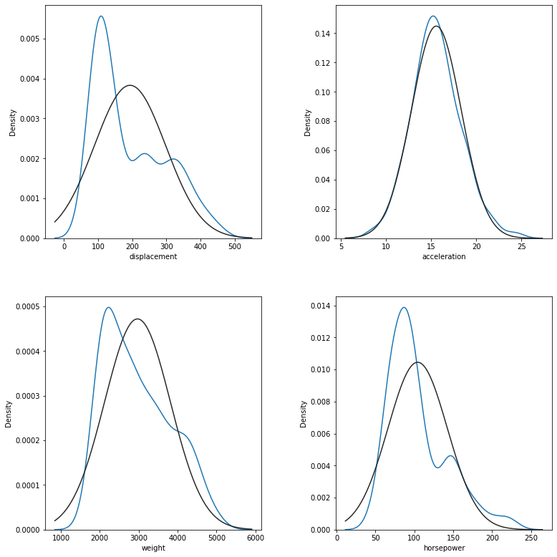
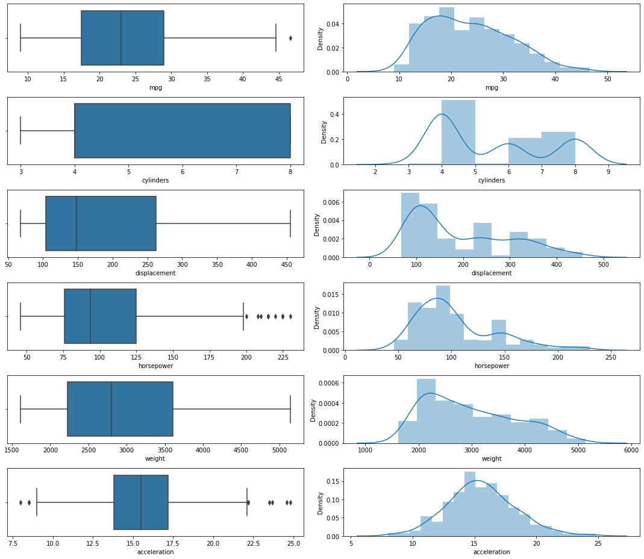
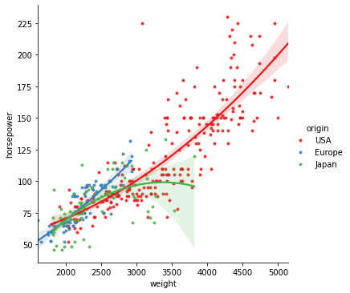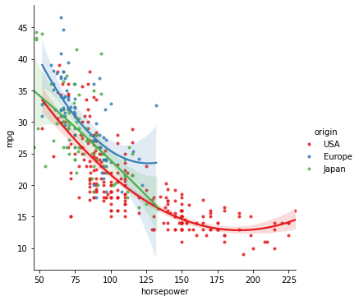

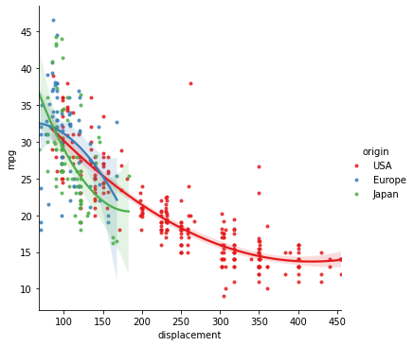
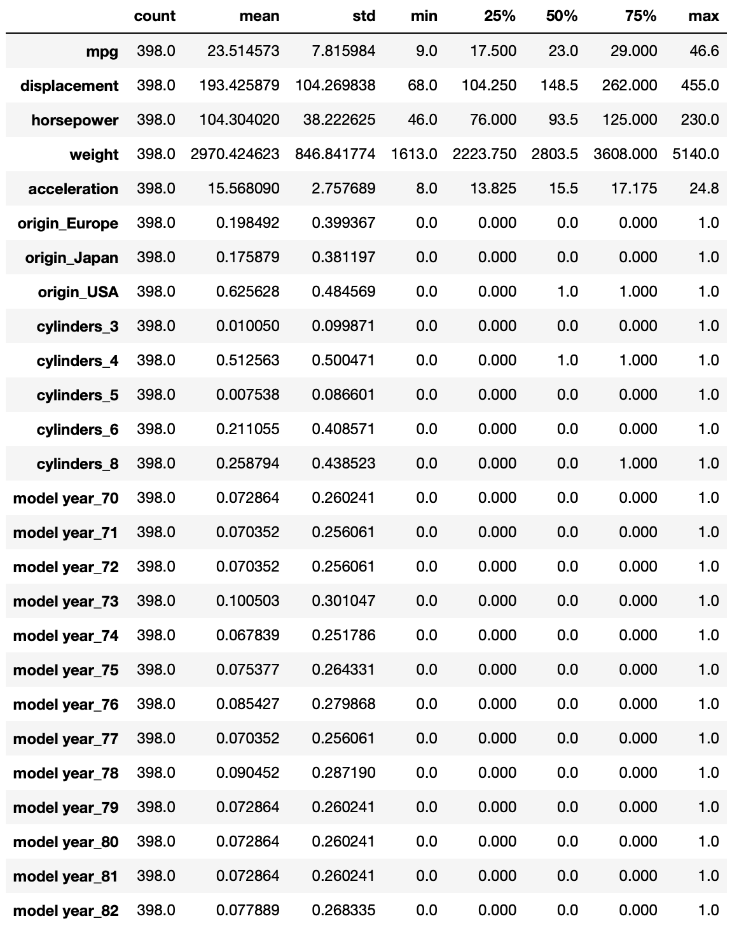
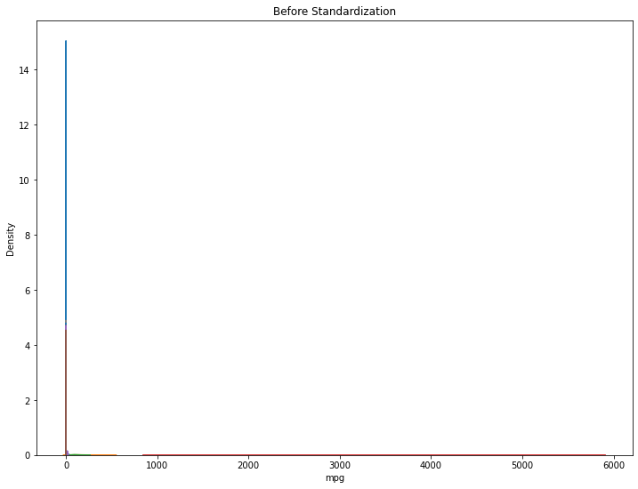

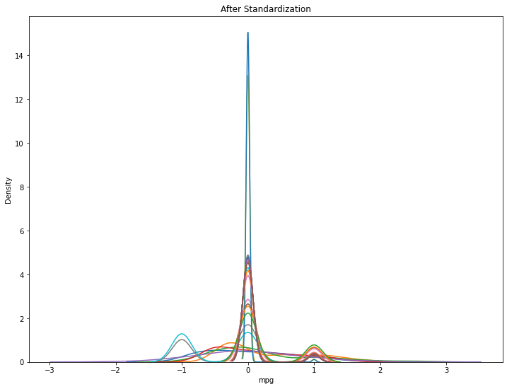
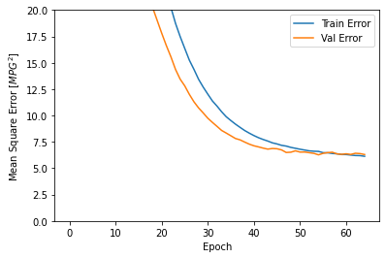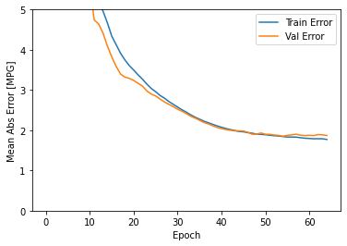

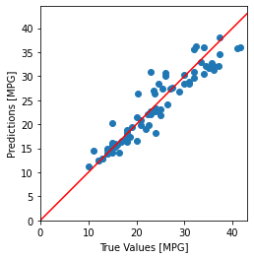

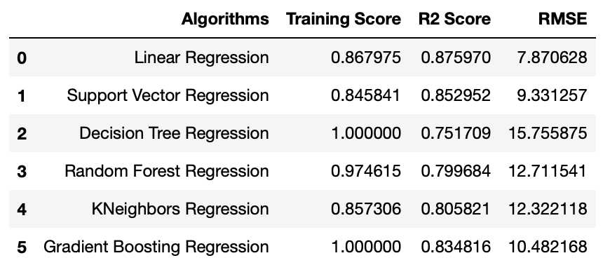

Credit Card Fraud

